SQL Views in PeopleSoft

In SQL views, a developer or DBA writes the SQL that is stored in the view statement. The parts of a SQL view are:

- Record definition
- Fields
- SQL

Creating SQL View NAIT###_COUN_VW

Follow these steps:
- Create the new record definition
- Insert the fields
- Save the record definition
- Set record field attributes
- Write the SQL Statement
- Build view

Step 1: Create the new record definition
Select File, New, Record

Step 2: Insert Fields
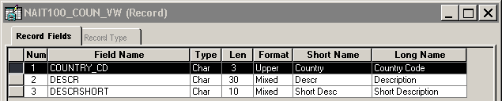

Step 3: Save the record definition
Record name NAIT###_COUN_VW

Step 4: Set record field attributes
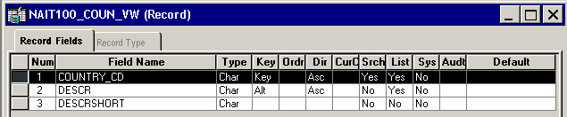

Step 5: Write the SQL statement
- Select the Record Type tab
- Select SLQ View
- Select the SQL Editor Button
- Type your SQL into the SQL window

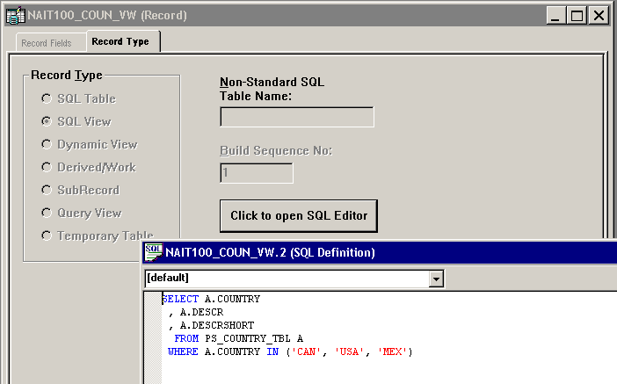

Step 6: Build the View

- Select Build, Current Definition
- Select Create Views
- Select Execute SQL now
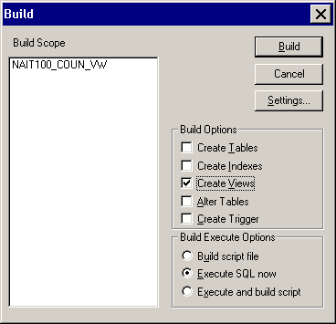

The Build process performs the following:
- It drops the existing view (if necessary)
- Builds the view placing a PS_ prefix before the record name (SQL only).

